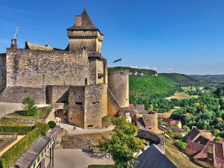

# Château de Castelnaud-la-Chapelle

The **Château de Castelnaud** is a medieval fortress in the commune of [Castelnaud-la-Chapelle](https://en.wikipedia.org/wiki/Castelnaud-la-Chapelle" \o "Castelnaud-la-Chapelle), overlooking the river [Dordogne](https://en.wikipedia.org/wiki/Dordogne_(river)) in [Périgord](https://en.wikipedia.org/wiki/P%C3%A9rigord" \o "Périgord), southern France. It was erected to face its rival, the [Château de Beynac](https://en.wikipedia.org/wiki/Ch%C3%A2teau_de_Beynac).

## **History**

The oldest documents mentioning it date to the 13th century, when it figured in the [Albigensian Crusade](https://en.wikipedia.org/wiki/Albigensian_Crusade" \o "Albigensian Crusade); its [Cathar](https://en.wikipedia.org/wiki/Cathar" \o "Cathar) castellan was Bernard de Casnac. [Simon de Montfort](https://en.wikipedia.org/wiki/Simon_de_Montfort,_5th_Earl_of_Leicester) took the castle and installed a [garrison](https://en.wikipedia.org/wiki/Garrison); when it was retaken by Bernard, he hanged them all. During the [Hundred Years' War](https://en.wikipedia.org/wiki/Hundred_Years%27_War), the castellans of Castelnaud owed their allegiance to the [Plantagenets](https://en.wikipedia.org/wiki/Plantagenet" \o "Plantagenet), the sieurs de Beynac across the river, to the king of France. In later times it was abandoned bit by bit, until by the [French Revolution](https://en.wikipedia.org/wiki/French_Revolution) it was a ruin.